 

# Placement Empowerment Program

***Cloud Computing and DevOps Centre***

Write the Shell Script to Monitor Logs : Create a script that monitors server logs for errors and alert you

Name: Harivasan S

Department: ADS



# Introduction :

Log files are essential in IT systems, capturing events, warnings, and potential security threats that require prompt attention. Automating log monitoring enhances efficiency and minimizes the risk of overlooking critical issues.

This **PoC** showcases the development of a **PowerShell script** for real-time log monitoring. The script will scan log files for specific keywords (e.g., **"error"**) and notify the user when such events are detected.

# Overview :

This project focuses on developing and executing a **PowerShell script** that monitors a log file in real time. The script will:

1. Continuously read the log file.
2. Detect new entries containing predefined keywords (e.g., **"error"**).
3. Generate an alert upon detecting a match.

# Step-by-Step Overview :

Step 1:

Create a Folder called logs for Your Logs and Script



Step 2:

Open Notepad and Add the following sample text to it and Save the file as **mylogssfile.log** inside the logs folder



Step 3:

Open Notepad and Type the following PowerShell script into it and Set the $LogFilePath address to the mylogfile.log which you saved in logs folder. Save the file as monitorlog.ps1 inside the same logs folder

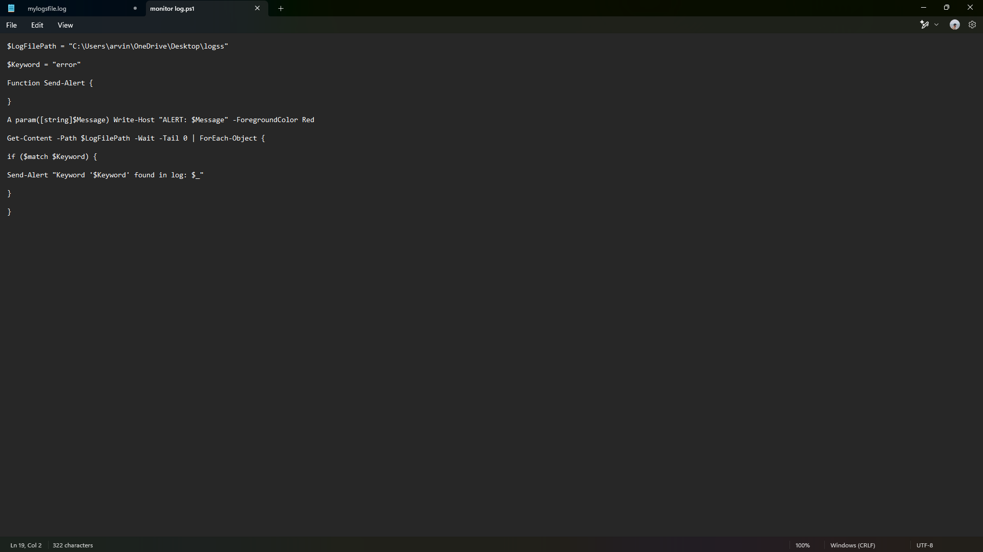

Step 4:

Click the Windows Key and Search for Windows PowerShell and click Run as Administrator.

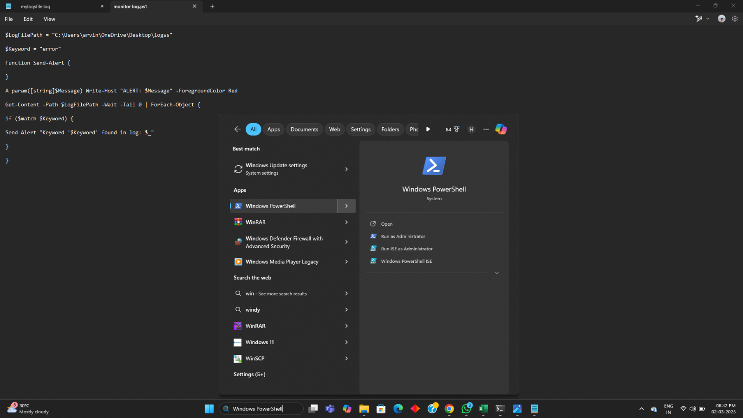

Step 5:

Run the following command to allow script execution:

## Set-ExecutionPolicy -Scope CurrentUser -ExecutionPolicy RemoteSigned

When prompted, type Y and press Enter.

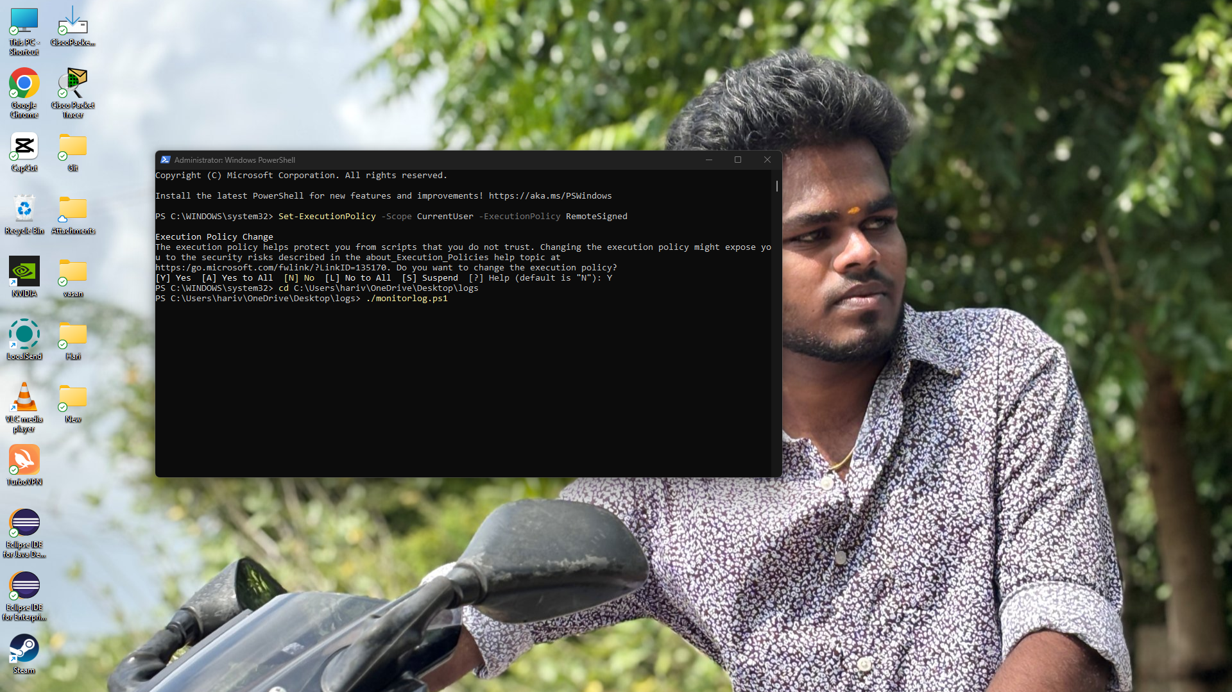

Step 6:



Step 7:

Open mylogfile.log in Notepad and Add a new line with the word

"error" and Save the file.



Step 8:

Check PowerShell — you should see an alert like:

**ALERT: Keyword 'error' found in log: error: A new issue occurred!**

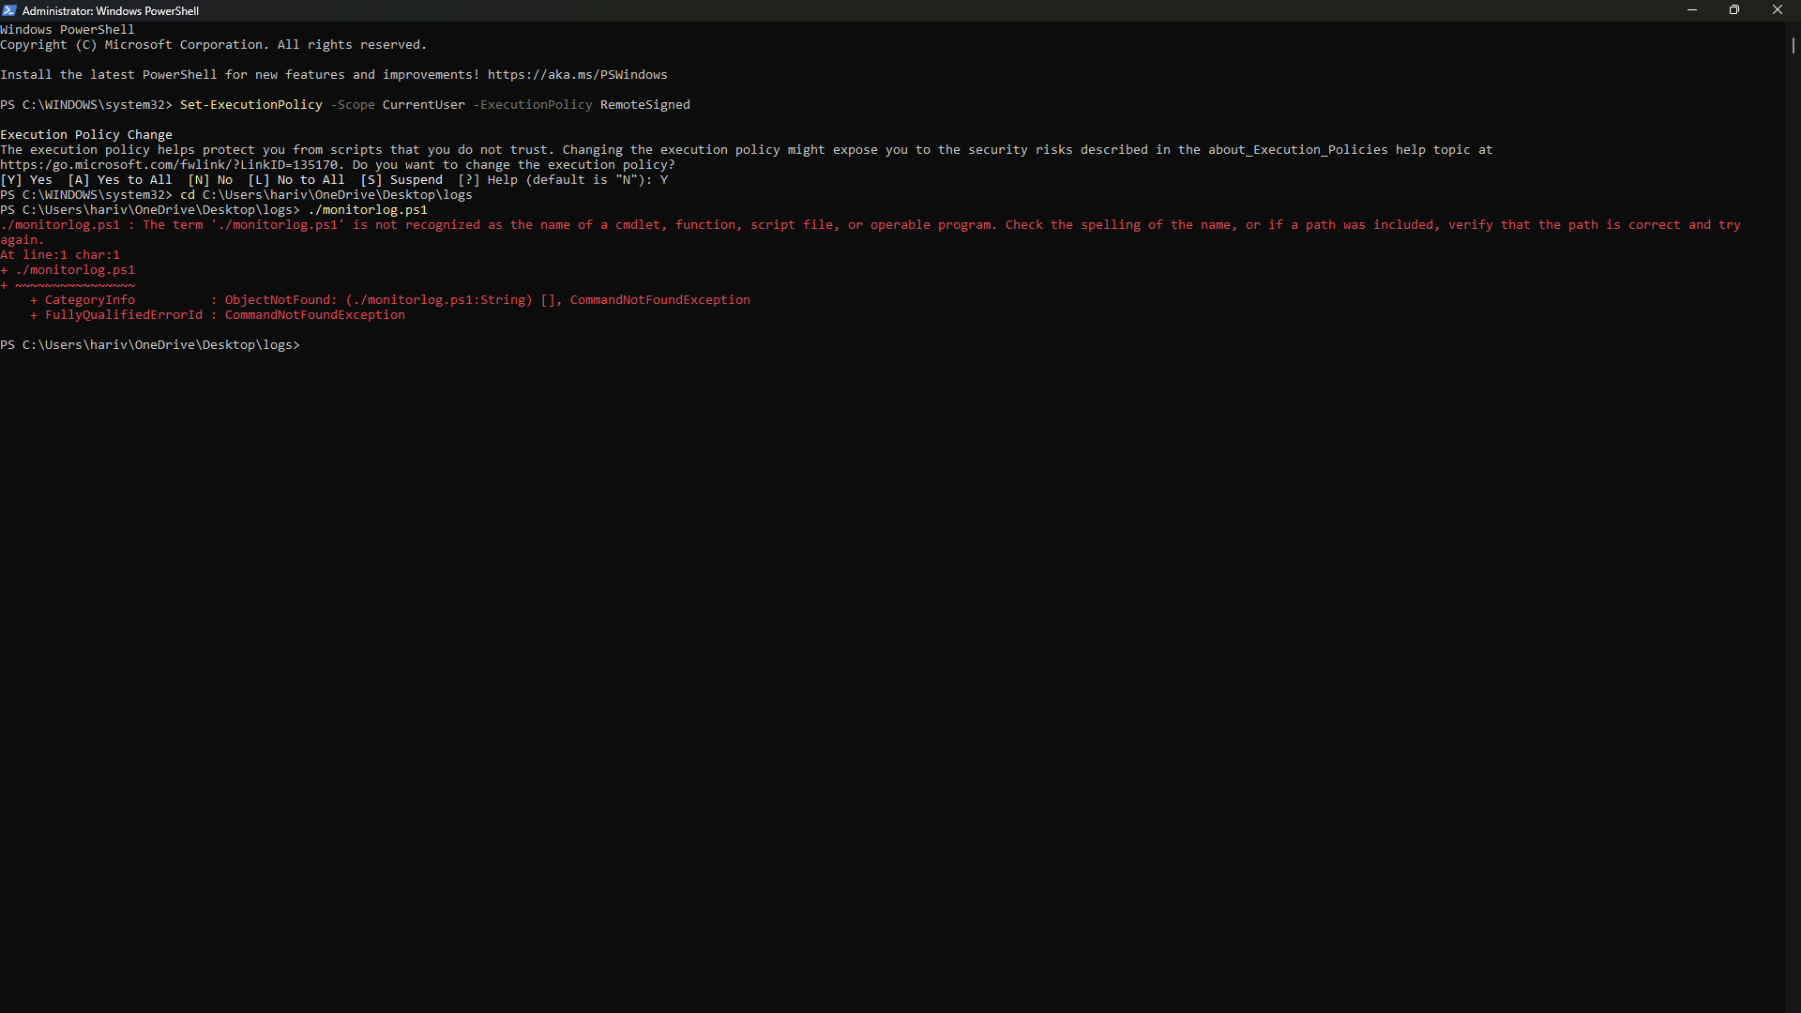

**Expected Outcome:**

1. Develop and run a **PowerShell script** for real-time log file monitoring.
2. Identify critical events by detecting and alerting on predefined keywords (e.g., **"error"**).
3. Gain practical experience in **PowerShell scripting** and **automation** on Windows.
4. Understand the significance of **log monitoring** in proactive system maintenance and troubleshooting.
5. Learn to **customize and scale** the script for advanced monitoring needs in future projects.